The Local Development Strategy (LDS)

LEADER provides rural communities, across the EU, with a method and the resources for local people to actively engage with and direct the local development within their own area. This is underpinned by a framework which requires the Local Action Group to design a Local Development Strategy for the delivery of LEADER activities.
The LDS is a community-led plan, developed and driven by rural communities, through the Local Action Group to achieve a particular vision and support the sustainable development of the area. The LDS is based on the seven key features that underpin the LEADER approach which are:
- Area-based local development strategies;
- Bottom up approach;
- Public-private partnerships - the LAG;
- Innovation;
- Integrated and multi-sectoral actions;
- Networking;
- Co-operation
The LDS seeks to address the identified needs of the area, whilst also exploiting its development potential and is based on a series of local objectives. Each objective must directly link to a LEADER theme and sub-theme. As LEADER is included under priority 6 of the RDP, the objectives should reflect a commitment to promoting economic development and social inclusion.
Community-Led Approach

The LDS is developed and implemented through a CLLD approach, which is all about local consultation and active participation of the rural community. This engagement includes the general population, area-based, sectoral and interest groups and representatives from the statutory, community and voluntary and private sectors. In the context of addressing rural social exclusion, it is critical that people living in disadvantaged areas and those from marginalised groups are actively engaged in the process.
Adopting a CLLD approach enables the local community to identify the needs of the area whilst also having an input into the type of actions that might be delivered through the LDS. The community-led approach also underpins the implementation of the LDS
Strategic Integration
The LDS and the actions contained within the strategy should reflect the 3 cross cutting objectives of the RDP.
1. Innovation;
2. Climate change
3. Environment
LEADER Themes /Sub-Themes

To facilitate a more effective targeting of resources, the RDP outlines a series of themes that were identified as overarching needs in rural Ireland, through consultation and research. These themes respond to key challenges facing rural Ireland, with regard to economic recovery, employment creation, tackling social exclusion and reducing the impact of global warming and resource depletion. Each theme is given further definition through a number of sub-themes which reflect the key areas that stakeholders believe require the most support and have the greatest potential to promote the sustainable development of rural communities. The sub-themes are considered to be sufficiently broad and flexible to encompass the diversity of local needs in rural areas and the range of projects supported through the LDS.

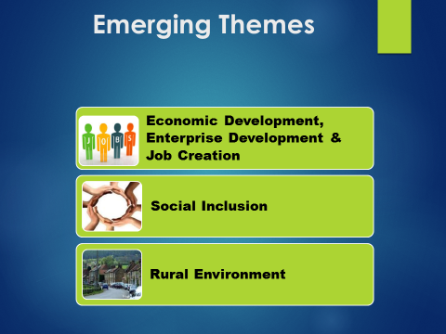
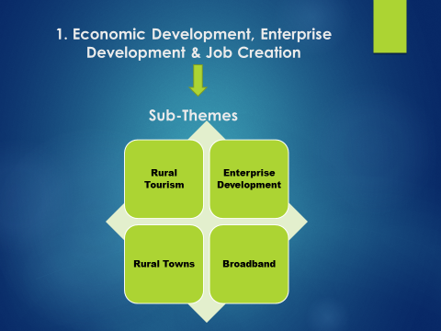

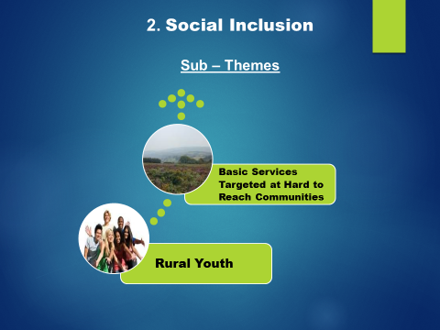

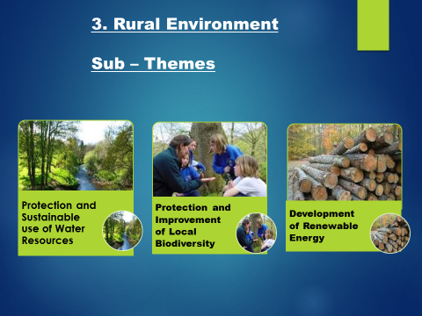

Theme 1 - Rural Tourism
Rural tourism is an important sector that provides a stimulus for enterprise and job creation. As tourism is based on a particular asset that is generally place-specific, for example, landscape, history, it offers significant potential, even in peripheral areas. While tourism actions are primarily aimed at attracting foreign visitors to an area this can be a challenge for the more peripheral rural areas who often struggle to engage with tourists unless, for example, the area is in the catchment area of a well-known attraction. Interventions under this sub-theme should focus on actions that have the potential to make the area more attractive for local, national and foreign visitors. Examples of actions that may be supported include feasibility studies to explore the tourism potential of an area, marketing initiatives and the creation of tourism hubs to facilitate a multi-sectoral approach. Activities that centre on the development and renovation of infrastructure are also an important contributor to historic and heritage-based tourism. Other actions that promote an innovative tourism sector include the development of cultural/heritage infrastructure of local significance and arts-based activities and events. The provision of amenity and leisure facilities can support adventure/eco-based tourism, which is a growing sector.
Enterprise Development
The significance of small and medium enterprises (SMEs) to the rural economy is demonstrated by the fact that SMEs account for 92% of all enterprises. It is evident however, that SMEs in rural areas face key challenges, as they are disproportionately at risk of closure with the economic downturn. To support the diversification of the rural economy, the CEDRA report (2014) identifies potential sectors for future enterprise development, which may be relevant to the development of local strategies, these include:
- Artisan Foods;
- Renewable Energy;
- Marine;
- Social Enterprises;
- Creative Industries.
Rural Towns
This sub-theme supports the regeneration of rural towns by promoting them as attractive places to visit, live and do business in. The CEDRA (2014) report outlines how many rural towns felt the impact of the economic downturn more acutely than urban areas, with high levels of unemployment and poverty. LEADER is particularly suited to revitalising rural towns through co-ordinating an integrated approach that builds on the economic strengths and infrastructure of the area whilst addressing the key challenges for business, community and recreation. Actions that support the regeneration of rural towns include town renewal schemes that renovate derelict buildings with incentives to attract business to vacant properties. The building or refurbishment of community buildings also provides a multifunctional infrastructure for social, cultural and sporting activities and training for the local community. The development and promotion of unique social events and activities, such as farmers’ markets, can provide an important stimulus to rural towns.
Broadband
Given the extent of work that is conducted online, increased access to reliable and high-speed broadband is vital for the economic and social development of rural areas and communities. High quality broadband enables businesses to set-up or continue to be based in rural areas, by overcoming barriers relating to access to markets and services. There is also a potential to create additional employment, as access to broadband can support businesses to grow. The National Broadband Plan (NBP) ‘Intervention Strategy’ was unveiled by the Department of Communications, Energy & Natural Resources (DECNR) in July 2015. Up to €500 million has been promised to deliver on its goals which are a minimum of 30 Mbps download and 6 upload by 2021. LEADER will not play a role in Broadband delivery as this would be duplication of resources. This sub- theme supports local actions that complement the national initiatives tasked with developing a comprehensive rural broadband infrastructure. Examples of actions include, basic ICT training to priority groups, for example, to enable older people and young people to stay connected.

Theme 2 - Social Inclusion
The focus of theme two, relates to promoting the cohesion of the sub-regional area not only from an economic development perspective but also in relation to fostering social inclusion. In rural areas, the low density of population, high levels of out-migration and distance from urban centres, results in fewer employment options and lower levels of service provision than in urban areas. In addition, the importance of rural transport in addressing social exclusion has been acknowledged for some time.

Provision of Basic Services Targeted at Hard to Reach Communities.
This sub-theme addresses a lack of access to basic services, for people living in rural and remote areas and groups who are at risk of social exclusion. In some cases, the particular service may have never existed in the locality or has been withdrawn. In rural areas, people’s experience of exclusion is often compounded by physical isolation. The type of actions supported may involve establishing a new service for hard to reach communities, or improving existing services. Examples of basic services include community facilities; education/training; social/cultural, recreational; retail and finance; personal support. Examples of particular groups who may be at risk of social exclusion include: people living in disadvantaged areas; people living in remote and less accessible areas; unemployed and underemployed people; fishermen and farmers on small holdings; women; children; lone parents, people with a disability; older people; people living alone; NEETs (Young People who are Not in Employment, Education or Training); migrants/new communities (including refugees/asylum seekers); local authority tenants; Travellers; Roma.
Rural Youth
The significant increase in unemployment levels across many EU countries has had a severe impact on young people. In 2014, the percentage of young people in Ireland who were not in employment, education or training (NEET) was 15.2%. Evidence suggests that the life-chances of young people in rural areas have been affected by lower levels of educational attainment, the decline of traditional sectors of employment and the out-migration of well-educated young people. The promotion of youth entrepreneurship and associated training can provide improved pathways for young people to access economic opportunities in rural areas. In addition, actions that develop the social infrastructure of rural areas provide important opportunities for young people to realise their potential. These include the provision of youth clubs/cafés; improved access to ICT; sports/recreation activities; arts-based projects; and youth development programmes. Young people, particularly those who may be vulnerable, also have distinct needs regarding the type of services they may need to access. In the context of LEADER, young people are defined as people aged 15 to 35 years.
Theme 3: Rural Environment
Theme three is focused on maximising the potential of the environment to contribute to the sustainable development of rural Ireland. This is premised on utilising the landscape within a local area and its features and natural resources, while simultaneously creating a greater environmental awareness and improving environmental protection.
Protection and Sustainable use of Water Resources.
Greater protection of local water resources is essential for sustaining rural communities. Environmental schemes have the potential to play a pivotal role in addressing pressures on water reserves and in supporting the local community to conserve this valuable resource.
Actions funded under this sub-theme may include, general awareness raising on water conservation issues, the development of local water conservation plans and feasibility studies. Capacity building on the technical aspects of water recycling schemes is also a key activity.

Local projects that could be funded under this priority include practical initiatives that conserve water, for example, community programmes for rain water harvesting and the use of greywater for fertiliser and general washing.
Protection and Improvement of Local Biodiversity
Biodiversity, which encompasses natural wildlife, flora and fauna, is an important foundation to the healthy functioning of ecosystems. The protection of biodiversity is a growing concern, with the loss of various species of wildlife, flora and fauna as well as their natural habitat. Factors that impact on local biodiversity include population growth, cutting hedgerows and changes in land usage. Examples of actions that promote local biodiversity include, awareness raising and practical guidance on how to protect biodiversity domestically. In addition, feasibility studies and action plans may focus on larger scale projects that enhance and protect particular aspects of biodiversity. Local projects that could potentially be funded under this priority include practical initiatives that support biodiversity and environmental improvements, for example, the upgrading of parks and river walks, establishment of nature corridors, habitat creation and planting of native species.
Development of Renewable Energy
Clean sources of energy have a lower environmental impact on nature than conventional energy technologies. This sub-theme is premised on the need to mitigate against the impact of recent environmental trends, which include climate change. It is considered that community-based initiatives will play a key role in realising national and EU environmental targets, particularly in the reduction of carbon dioxide emissions through energy infrastructure. In addition, renewable energy technologies have the potential to generate new employment opportunities in rural areas. Examples of actions that may be supported include general awareness raising on environmental issues and feasibility studies relating to green technologies. Capacity building actions may focus on the installation and use of renewable energy technologies. Local projects that could potentially be funded include technologies that deliver sustainable energy alternatives, for example, biomass heating, solar power, community wind farms and community-based heating systems.

