County Wicklow Partnership

Panel of Trainers and Facilitators

2024-2028

For Social Inclusion Community Activation Programme
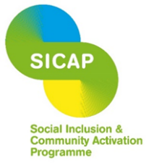
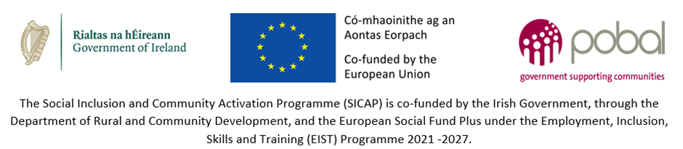

PANEL OF TRAINERS
RESPONSE DOCUMENT

Award of a Contract for | Panel of Trainers and Facilitators  For Social Inclusion Community Activation Programme; 2024-2028
Procedure | OPEN
Issue Date | Friday 12th January 2024
Tenderer Instructions | Fully completed response document, CV and copies of relevant qualifications should be submitted in writing, in a sealed envelope to:  FAO: SICAP Coordinator  Panel of Trainers and Facilitators  County Wicklow Partnership  Avoca House, Bridgewater Shopping Centre,  Arklow, County Wicklow

COMPANY/INDIVIDUAL DETAILS
Main Contact Person:
Position:
Address:
Phone:
Email:
Website:

SELF DECLARATION RE TAX COMPLIANCE AND INSURANCE
TAX CLEARANCE & INSURANCE
If awarded a contract I confirm I can declare tax compliance from the Irish Revenue Commissioners: I can confirm in writing that our/my tax affairs are in order or alternatively I can provide details (PPS Number or Tax Reference Number and Tax Clearance Access Number) for tax clearance certificate verification online | Signed:  __________________________  Position: __________________________  Date:______________________
If awarded a contract I declare that I will indemnify County Wicklow Partnership and Pobal in respect of any action on account of loss, damage or injury caused by the tutor, their employees or agents in relation to the contract and I will have appropriate insurance in place. | Signed:  __________________________  Position: __________________________  Date:______________________

DETAILS OF COURSES WHICH COULD BE DELIVERED
Note: Please include a full CV with your application and copies of relevant qualifications (e.g. certificates) for all tutors who may form part of any future tendering contract for successful tenderers.
Name of all facilitators/trainers forming part of this submission:
Tutor Name: | Proposed Role (Courses this individual could deliver): | Confirmation: Copy of CV & where relevant copy of qualifications included with this submission Yes/No

TRAINING METHODOLOGY AND QUALITY OF OFFER

Methodology and quality of offer
Include a detailed outline of the courses you would propose to deliver, your proposed approach to training and/or facilitation work and how it is to be implemented. Details of the course content to be provided.

Optional: Samples of previously delivered training or detailed lesson plans can be provided to demonstrate the methodology to be used.
[Insert response]

OUTLINE OF PRICE

Include a detailed breakdown of either hourly or daily costs which include expenses and other incidentals. As this is a training initiative, VAT does not apply.
[Insert response]

I/We confirm that
In relation to daily/hourly fees all rates are inclusive of out of pocket expenses (i.e. mileage, preparation of course material, subsistence, phone, postage, course material printing, certification fees, etc.) and contract management related costs.
Signed: __________________________ Date: _____________________

PREVIOUS EXPERIENCE AND TRACK RECORD
Please provide details of two previous examples of work undertaken for a similar contract and provide two references from organisations you have worked with and outline when this work was undertaken. CWP reserves the right to check references.

CONTRACT
Start Date - End Date
Client Name & address
Client contact person: |  | Phone no.:
Client email address:
Details of service provided

CONTRACT
Start Date - End Date
Client Name & address
Client contact person: |  | Phone no.:
Client email address:
Details of service provided

DECLARATION RE: DATA PROTECTION AND SECURITY
I/ We confirm that all Data Subjects whose Personal Data is provided in and with this response document, in order to be included on CWP’s panel of trainers and facilitators, have consented to the submission and processing of such Personal Data by us, the Contracting Authority and the Evaluation team, for the purposes of our participation in this Call for Panel of Trainers and Facilitators.
Signed: __________________________ Date: _____________________
County Wicklow Partnership confirms that these documents will be stored in a secure location and will only be used for its intended purpose.

